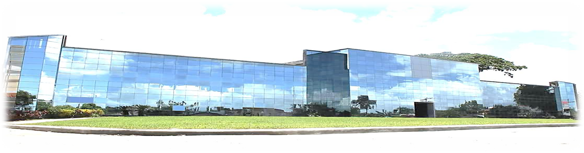
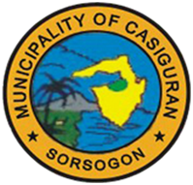
Republic of the Philippines
Province of Sorsogon
MUNICIPALITY OF CASIGURAN

BAC Resolution Declaring LCRB and Recommending Approval

RESOLUTION NO. – PB-CW-0000-00-000

WHEREAS, the Local Government Unit of Casiguran posted and advertised the Invitation to Bid for {{project_title_upper}} at the PhilGEPS’s (Philippine Government Electronic Procurement System) website on DATE and posted in a conspicuous place from DATE– DATE. The Approved Budget for the Contract is Php {{approved_budget}}.

WHEREAS, in response to the said advertisements and publication, there were {{total_interested_bidders_lower}} interested bidders who submitted letter of intent and {{number_of_responsive_bidders}} of these bidders purchased bidding documents and submitted bid proposals on time, namely: {{bidders_upper}}

WHEREAS, upon evaluation of technical component, the BAC determined that the six bidders were eligible and rated them as “pass”. Their bid proposals were found to be complete.

Whereas, upon evaluation of financial documents it appeared that the bid proposal of AZLJ CONSTRUCTION is considered the lowest calculated bid.

Name of Bidder | Bid Amount  (As Read) | % Variance from ABC
AZLJ CONSTRUCTION | amount

WHEREAS, the detailed evaluation of bids conducted from DATE resulted in the following:
Name of Bidder | Bid Amount (As Calculated) | % Variance from ABC
AZLJ CONSTRUCTION | amount

WHEREAS, upon post-qualification or careful examination, validation and verification of all the eligibility, technical and financial requirements submitted by the Bidders with the Lowest Calculated Bid, AZLJ CONSTRUCTION, its bid has been found to be responsive;

NOW, THEREFORE, We, the Members of the Bids and Awards Committee, hereby RESOLVE as it is hereby RESOLVED:

- To declare AZLJ CONSTRUCTION as the Bidder with the Lowest Calculated Responsive Bid for the CONSTRUCTION OF A DECORATIVE FENCE AROUND POBLACION, CASIGURAN SORSOGON,

- To recommend for approval by the Municipal Mayor – Maria Minez R. Hamor of the Local Government Unit of Casiguran the foregoing findings.

RESOLVED, at the BAC’s Office Municipal Hall, Casiguran, Sorsogon this ___________________.

NORINA R. DUQUE MERLIN H. GABITAN
BAC Member BAC Member

AVA AISA DE CASTRO-RENIVA ALONA A. SAYSON
BAC Member BAC Member

ARLIE H. CORAÑES
BAC Chairman

Approved by:

MARIA MINEZ R. HAMOR
Municipal Mayor

Date approved: _____________________

